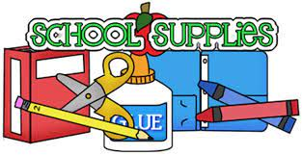

K3  Backpack  2 Folders  Small Plastic Pencil Box-not pouch  1 box of sandwich Ziploc bags  1 box gallon Ziploc bags  2 Crayola watercolor paint set  2 Crayola crayons 8 count (jumbo)  1 box Crayola markers  1 bottle Elmer’s glue  Kid blunt edge scissors  1 pack multicolored expo markers  3 rolls of paper towels  2 liquid hand soaps  1 large box (multi pack) baby wipes  1 Clorox wipes  2 box family size of goldfish/animal crackers  2 Extra sets of clothes in a Ziploc bag with name  Full time students-pillow and blanket  Easy open water bottle  2 reams of copy paper | K4 (Initial Everything)  Backpack  2 folders  Small Plastic Pencil box-not pouch  2 sharpened pencils  2 Crayola watercolor paint set  1 Crayola crayons 8 count (jumbo)  2 Crayola crayons 16 count  2 boxes Crayola markers  2 bottles Elmer’s glue  6 jumbo glue sticks-purple  Kid scissors  1 ream of copy paper  Large 3 in. binder (white with clear view plastic on front)  2 rolls of paper towels  2 individual size play-doh  1 pink eraser  1 hand sanitizer  2 packages of baby wipes  2 Clorox Wipes  1 box family size animal crackers/goldfish  Extra set of clothes in a Ziploc bag with name  Full time students-nap mat, pillow, and blanket  Water bottle

